Name:________________________ Period:___________

Biological Psychology Reading Guide (Chapter 3 in textbook, Chapter 3 Barron’s)

1. Please describe the five basic parts of the neuron.

2. Which ions are positively charged? Which ions are negatively charged?

3. What is the all-or-none law?

4. Please label the different parts of this synapse.

1. 2. 3. 4. 5.

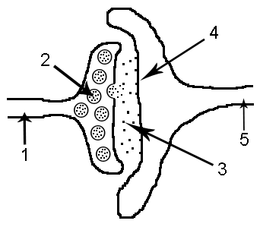

5. Explain the process of neural transmission.

6. What do agonists do? What do antagonists do?

7. Neurotransmitter What does it do? Disorders (specify whether surplus or deficiency)
Acetylcholine (ACh)
Dopamine
Norepinephrine
Seratonin
GABA
Glutmate
Endorphins

8. Explain the difference between afferent neurons and efferent neurons.

9. Which nervous system and divisions are involved in the fight or flight response? Explain how.

10. Which brain imaging procedures show structure only.

11. Which brain imaging procedure shows function only.

12. Which brain imaging procedure shows both structure and function?

13. What parts make up the hindbrain? Describe function of each part.

14. What is the midbrain responsible for?

15. What parts make up the forebrain? Describe the function of each part.

16. Why is the pituitary gland called the master gland?

