Freud’s Theory of the Mind’s Structure
Visual Metaphor
Extra Credit

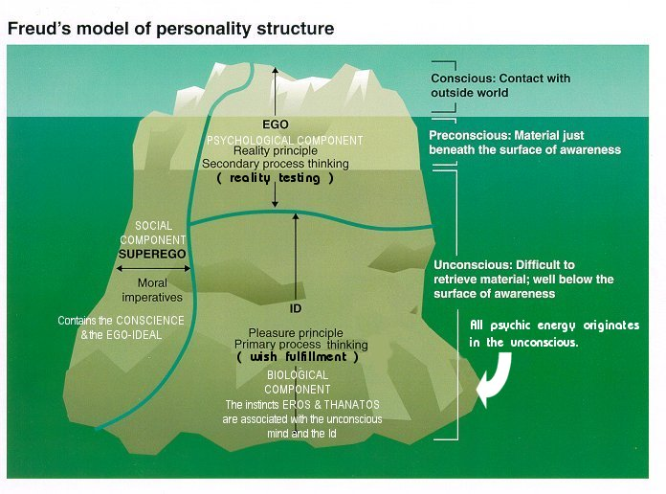

Your textbook uses the classic metaphor of the iceberg to describe Freud’s theory of the mind’s structure (see page 480). Your job is to create a different metaphor to describe Freud’s idea of the mind’s structure.
Be sure to include the concepts of:

- Ego
- Superego
- Id
- Conscious mind
- Preconscious mind
- Unconscious mind

This is worth up to 10 extra credit points.

