Motivational Theories Playlist Activity
Task: In your cohorts, create 4 music playlists for the different theories of motivation that we discussed. Each playlist should have at least 4 songs in which the title, lyrics, or overall meaning of the song relate to the theory's explanation of motivation (please keep them school appropriate). Using the paper provided, make a “giant” iPod/iPhone using the image below (or similar to it) and fill in your 4 new motivation playlists with their respective songs.
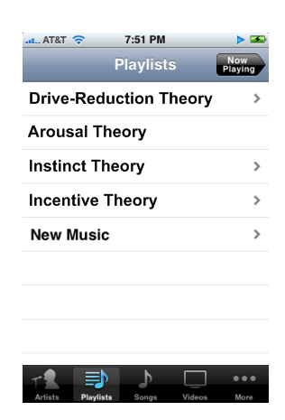
Playlists:
- Drive Reduction
- Instinct Theory/Evolutionary
- Arousal Theory
- Incentive Theory

Examples to help you (DON’T USE THESE):
Incentive theory
“Applause”- Lady Gaga
Drive reduction
“Hot in Herre”- Nelly

