Brainational Capitol
An international cafe.
Appetizers:
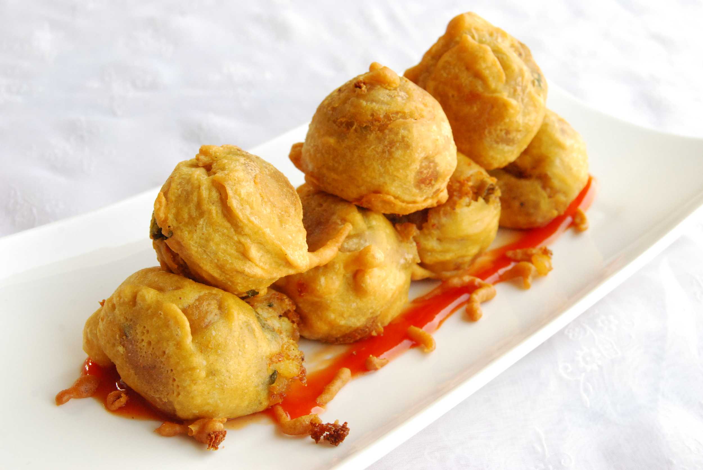
Ponda (India)
Having trouble breathing? Fear not PONDA is here! This delicious dish from India will catch your breath! Perhaps you feel disconnected and confused, PONDA promises to accelerate communication between your brain. Not only that but you will see better! Hear better! And smell better!

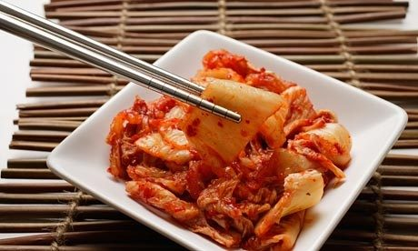
Kimpituarychi (Korea)
Welcome the newest most exquisite pitu-plate from Korea. Not only will this plate will be pleasurable to your taste buds but your emotion will be also thankful to you! You will be worry free of sweat and control for a short exquisite time how you wish to feel! Have the need to grow a few inches? Fear not! And welcome KIMPITUARYCHI!

Soups & Pastas:
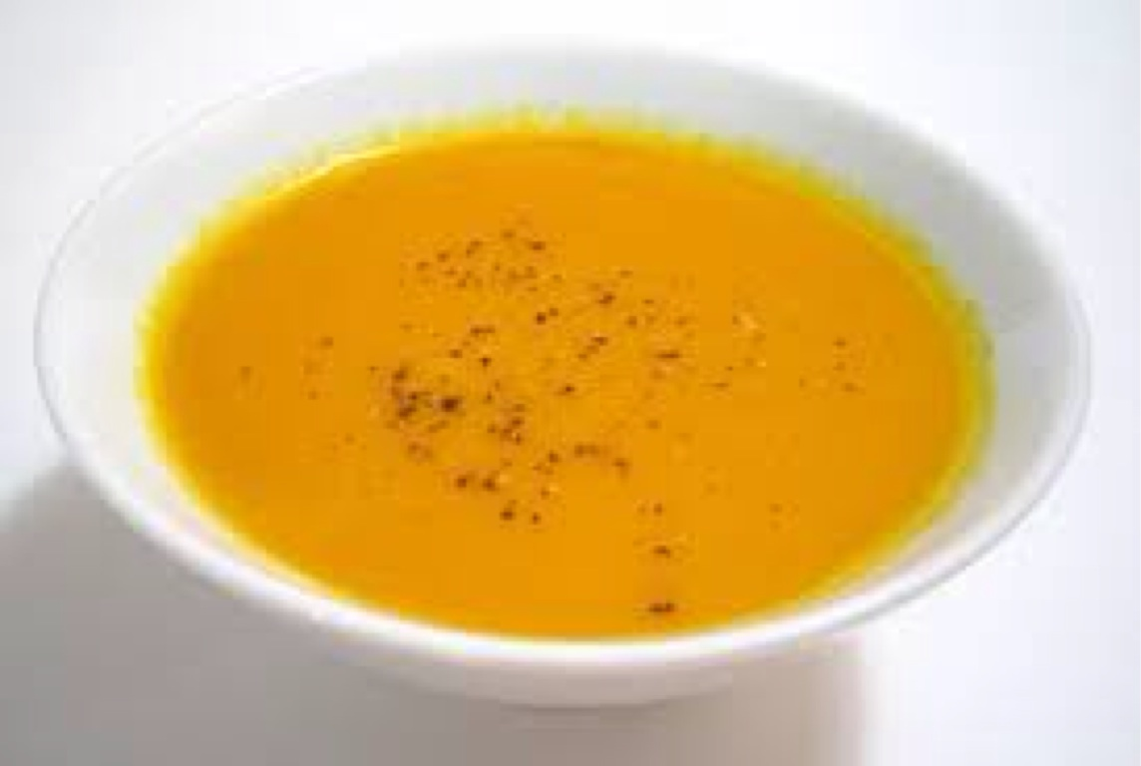

Traditional Occipital lobe soup (Middle East)
Occipital Lobe soup is a traditional dish in the middle east seasoned with Baharat and served with pita on the side. The popular soup is known to enhance visual reception.

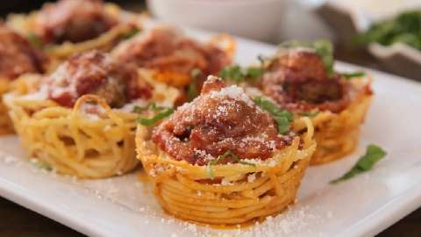
Thaghettus w/ Thalamus (Italy)
Thaghettus with Thalamus is one of the most popular dishes
From Italy. The Thaghettus is carefully wrapped around the meat Thalamus and is famous for helping your brain receive sensory signals and sending them to the correct place in the cerebral cortex.

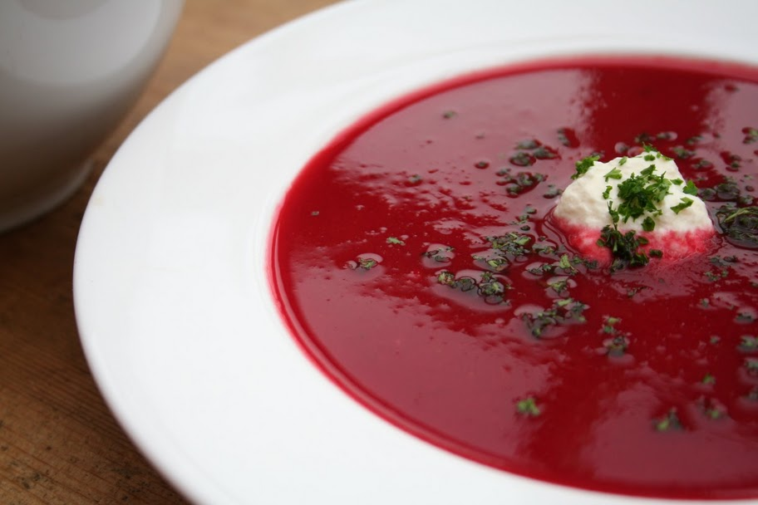

Hippocampus soup (China)
Hippocampus Soup is made with fresh tomatoes, hippocampus and a small portion of beets for color. This delicious hippocampus soup is something you will never forget because it helps maintain long-term memories,

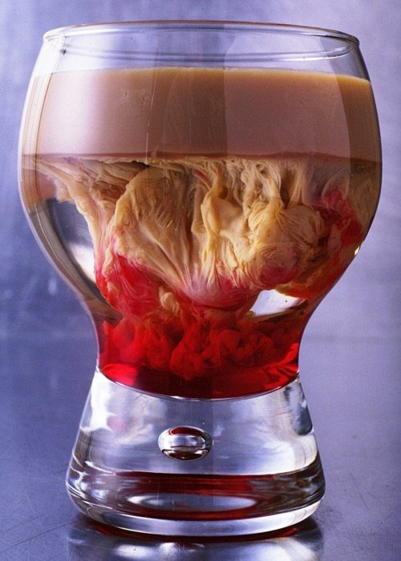
Beverages:

Merguedullas (Spain)
Ever tasted the sweet taste of blood running, or heard the low hum of YOUR breathing? Well now you can. With this drink you'll be able to feel digestion, your sneezing, and swallowing like never before!

LimbiCoquito (Puerto Rico)
LimbiCoquito is a coconut-based beverage traditionally served in Puerto Rico. It is made with rum, coconut milk, sweet condensed milk, vanilla, cinnamon, and limbic bits. This traditional beverage enhances memory and motivation.

Pastries:
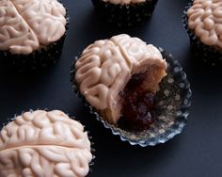
Ceresweet bellum (France)
Run to taste the wonders of this delicious cupcake who promises to strengthen your muscles. It will NOT knock you off your feet but make you stand on point.

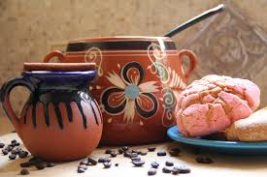
Cafe de Olla con Hypothalamus (Mexico)
This traditional Cafe de Olla is sweetened with hypothalamus which is known to enhance physical activity. It can help control body temperature, and help regulate sleep. It is served with your choice of Pan Dulce including conchas, mantecao and bolillitos.

