Insight therapies: designed to help clients understand the causes of their problems. This understanding or insight will then help clients gain greater control over their thoughts, feelings, and behaviors.

- Psychoanalytic/Psychodynamic therapy: based on Freud’s premise that unconscious conflicts and repressed memories are the underlying cause of anxiety and abnormal behavior. During psychoanalysis, the analyst helps the patient gain insight into how childhood conditions during the psychosexual stages created unconscious conflicts. Insight does not occur easily or quickly. During psychoanalysis, the therapist is removed from view of the patient as the patient lies on a couch and partakes in free association. The following can occur during psychoanalysis:

- Free association: the patient spontaneously reports thoughts, feelings, and mental images that come to mind. The psychoanalyst asks questions to encourage the flow of associations in order to provide clues as to what the patient’s unconscious wants to hide.

- Dream interpretation: Freud believed that dreams are symbolic representations of unconscious conflicts and repressed impulses. He also believed that dream interpretation is a means of interpreting their unconscious conflicts, motives, and desires. Psychoanalysts look at the latent (underlying) content as opposed to the manifest (storyline) content.

- Resistance: the patient’s conscious or unconscious attempt to block disturbing memories, motives, and experiences. To overcome one’s resistance, the analyst may use the Rorschach inkblot test or Thematic Apperception Test to help alleviate the blocking.

- Transference: the process by which a patient projects or transfers unresolved conflicts and feelings onto the therapist. Freud believed that transference helps patients gain insight by reliving painful past relationships.

- Psychodynamic therapy: less expensive and extensive therapy. The analyst is face-to-face with the patient, instead of being removed from the patient’s line of sight. Therapy focuses on childhood conflicts but not so much unconscious conflicts.
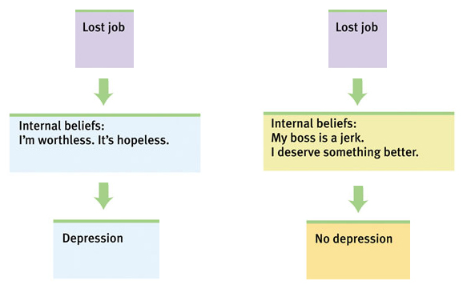
- Cognitive therapy: believes that faulty thoughts, such as negative self-talk and irrational beliefs, cause psychological problems.

- Rational emotive (Behavioral) therapy (RET/REBT): developed by Albert Ellis who said that our feelings are actually produced by the irrational beliefs we use to interpret events. To help clients recognize and change their self-defeating thoughts, Ellis developed the ABCs or RET:
- Activating event: identify the event that affected your mental process or behavior.
- Belief systems: identify the irrational beliefs and negative self-talk.
- Consequence: irrational beliefs lead to self defeating behaviors, anxiety disorders, and depression.

- Cognitive Triad therapy: developed by Aaron Beck to help clients come to grips with negative beliefs about the following:
- His/herself
- His/her world
- His/her future

- Modeling: exhibiting the way a person should thinking about thinks in a certain situation.

- Role playing: assuming a role of a different person or situation to act out how someone is feeling or thinking.

- Humanistic therapy: believing that people are innately good and motivated to achieve their highest potential instead of viewing human nature as irrational or self-destructive. Humanistic therapy believes that when people are raised in an accepting atmosphere, they will develop healthy self-concepts and strive to find meaning in life.

- Insight therapy: attempting to reduce the inner conflicts that are impeding natural development by increasing the awareness of underlying motives. Focuses more on the present and future than on the past; and, focuses more on the conscious than the unconscious.

- Existential analysis: looking at the philosophical questions of a person’s thoughts: What is the meaning of life? Where am I going in life?

- Gestalt therapy: developed by Fritz Perls, therapy aimed to emphasize the need for clients to fully acknowledge and experience their feelings, thoughts, and to become more self-aware and self-accepting. Focus more on how one feels instead of why one feels, uses the empty-chair technique in which a patient sits in front of an empty chair and imagines that the person to whom s/he needs to express his/her feelings is in the chair. The person then expresses his/her feelings to the person as if s/he were there.

- Client-centered (person-centered) therapy: one of the most widely used models in psychotherapy today. It involves creating a comfortable, non-judgmental environment by demonstrating empathy, genuineness, and unconditional positive regard toward the patients. Rogers believed that the term patient implied that the individual was sick and seeking a cure from a therapist. By using the term client instead, Rogers emphasized the importance of the individual in seeking assistance, controlling their destiny and overcoming their difficulties. Client-centered therapy uses the following:

- Non-directive approach: clients are encouraged to freely find solutions to their problems instead of the therapist telling them what they should do.

- Active listening: echoing, restating and seeking clarification of what the client is expressing.

Behavior therapy: focuses on the problem of behavior itself, rather than on the insights into the behavior’s underlying cause.

- Conditioning: a process of behavior modification by which a subject comes to associate a desired behavior

- Counterconditioning: undoing a learned behavior.

- Exposure therapy: exposing patients to things they fear and avoid. Through repeated exposures, anxiety lessens because the patients habituate (are no longer stimulated) to the things they feared.

- Flooding: exposing the patient to the thing he fears or avoids by immediately facing it instead of gradually facing it, like Fear Factor.

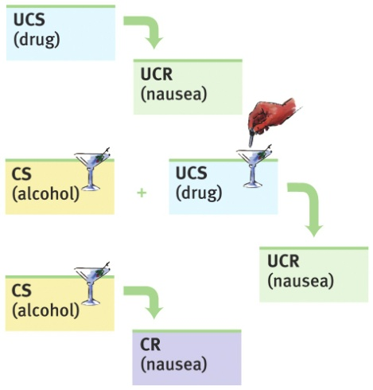
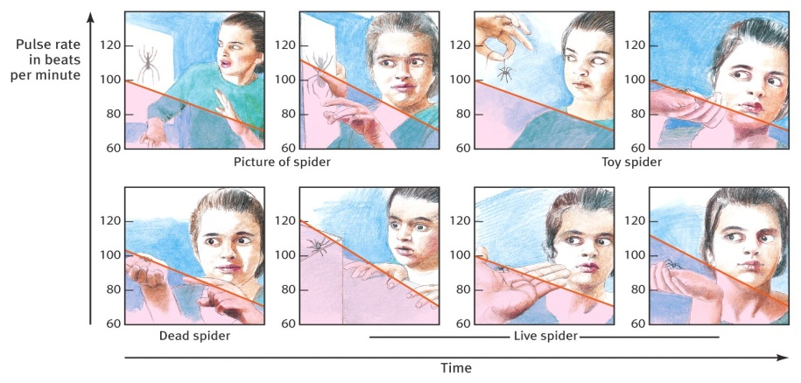
- Systematic desensitization: developed by Joseph Wolpe, an exposure technique that uses principles of classical conditioning to reduce anxiety by first exposing a client to a very low level of the anxiety-producing stimulus. Once anxiety is no longer present, the client is gradually exposed to stronger and stronger versions of the anxiety-producing stimulus. This continues until the client no longer feels any anxiety toward the stimulus. Virtual reality exposure therapy: Exposure therapy involves exposing people to fear in virtual environments.

- Aversion therapy: uses principles of classical conditioning to create anxiety (opposite of systematic desensitization that uses conditioning to reduce anxiety). The therapist deliberately pairs an unpleasant (aversive) stimulus with a maladaptive behavior.

- Token economy: getting something for good behavior, such as tickets, that can be turned in at a later time for a reward.

Group, family, and marital therapies: working with small groups of clients.

- Group therapy: a number of people meet and work toward therapeutic goals. Although group therapists can and do draw upon a variety of therapeutic approaches, they often base their sessions on the principles of humanistic therapy developed by Carl Rogers. Self-help groups offer a popular variation on group therapy. One of the best-known self-help groups is Alcoholics Anonymous.

- Family and marital therapies: strive to identify and change maladaptive family interactions.
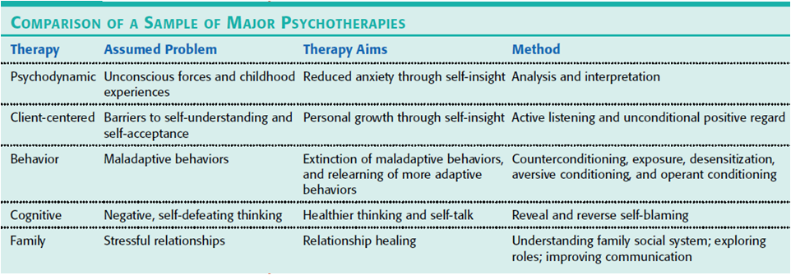

Biomedical therapy: based on the premise that the symptoms of many psychological disorders involve biological factors, such as chemical imbalances disturbed nervous system functions, and abnormal brain chemistry. In order to treat disorders, biomedical therapy uses drugs or brain stimulation.

- Psychopharmacology (chemotherapy): the study of how drugs affect mental processes and behavior.

- Antianxiety drugs (psychotropics): designed to reduce anxiety and produce relaxation by lowering sympathetic activity in the brain. Valium and Xanax (Zan-ax) are the best-known antianxiety drugs.

- Antipsychotic drugs (neuroleptics/major tranquilizers): designed to diminish or eliminate positive symptoms of schizophrenia, such as hallucinations, delusions, and other symptoms of schizophrenia. They work by decreasing activity at the dopamine receptors in the brain. Haldol and Thorazine are the best-known antipsychotic drugs. Atypical antipsychotic drugs, such as Clozaril, work to reduce the negative symptoms of schizophrenia. Long-term use of antipsychotic drugs can produce tardive dyskinesia (a movement disorder characterized by involuntary movements of the tongue, facial muscles, and limbs).

- Mood-stabilizing drugs: designed to treat the combination of manic episodes and depression characteristic of bipolar disorder. Lithium is the best-known drug for treating bipolar disorders.

- Antidepressant drugs: designed to treat depression by inhibiting the reuptake of the serotonin. Prozac is the best-known and most widely used SSRI (selective serotonin reuptake inhibitor – blocks the reuptake of serotonin).
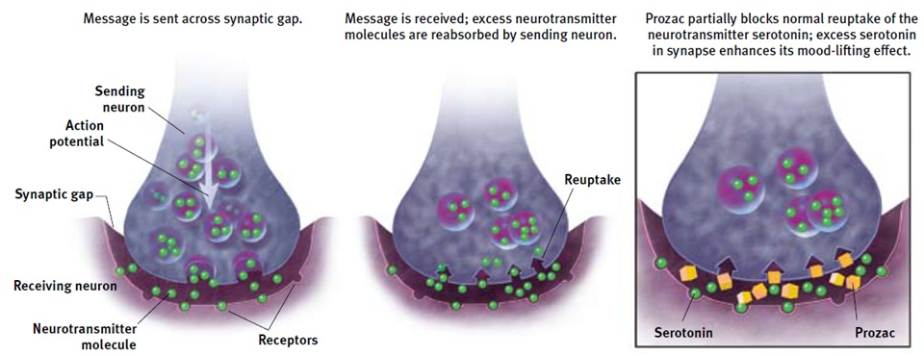

- Brain stimulation: a method of stimulating the brain through electrical currents.

- Electroconvulsive therapy (ECT): used to treat serious cases of depression. Because it works faster than antidepressant drugs, ECT is often used to treat suicidal patients. It involves placing two electrodes on the outside of the patient’s head and passing a moderate (100 volts) amount of electrical current through the brain.

- Repetitive transcranial magnetic stimulation (rTMS): an alternative to ECT that involves placing a pulsating magnetic coil over the prefrontal regions of the brain, treats depression with minimal side effects.

- Psychosurgery: the most dramatic and least used biomedical intervention for changing behaviors, involves removing or lesioning brain tissue, process is irreversible.

Regression toward the mean: the tendency unusual events or emotions to turn to their average state. Thus, feeling low, for example, tends to be followed by a return to normal.

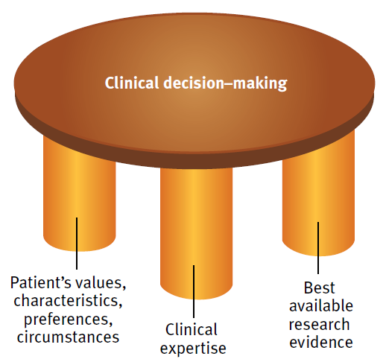
Meta-analysis: a procedure for statistically combing the results of many different research studies.

Evidence-based practice: the ideal clinical decision-making technique upheld by research evidence, clinical expertise, and knowledge of the patient.
Touch therapy: energy therapy which claims to promote healing and to reduce pain and anxiety. The therapist places his hand on or near a patient and detects and manipulates the patient’s energy field.
Eye movement desensitization and reprocessing (EMDR): rapidly moving one’s eyes while recalling traumatic events that were previously frozen.
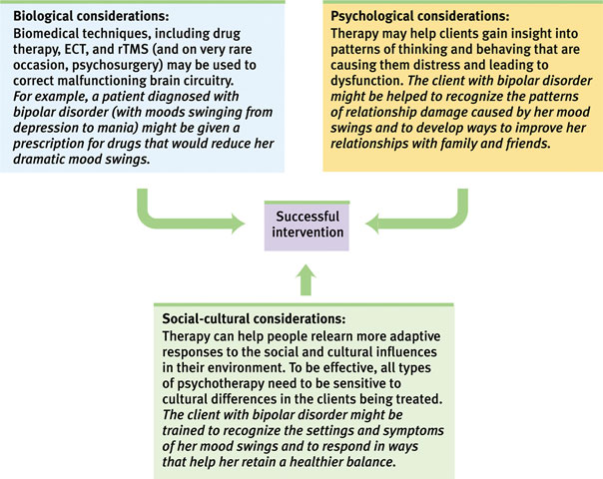
Light exposure therapy: treatment that is used to primarily treat seasonal affective disorder, therapy is given with a specialized box that emits light of greater intensity than is produced by outside light or indoor fixtures.

Therapy Key People:
Albert Ellis: developed Rational Emotive (Behavioral) therapy.

Aaron Beck: developed the Beck Depression Inventory and Cognitive Triad therapy. Beck believes that depression-prone people are particularly susceptible to focusing selectively on negative events while ignoring positive events. In addition, depression-prone people typically engage in all-or-nothing thinking by believing that everything is either totally good or totally bad.

Fritz Perls: developed Gestalt therapy.

Carl Rogers: humanist psychologist who developed client-centered (person-centered) therapy.

Mary Cover Jones: considered “the mother of behavioral therapy.” She conducted the Peter study which involved counterconditioning.

Joseph Wolpe: developed systematic desensitization.

