History of Brazil  Before colonial times, many indigenous and complex tribes settled in Brazil, such as the Marajoara Culture. The Marajoara were focused on the Marajo Island at mouth of the Amazon River. The mound building and sophisticated pottery of this culture showed major complexity in the region. In 1500, the Portuguese landed in Brazil and claimed it for their crown. After over 300 years later, the son of the Portuguese king declared independence and became the First Emperor of Brazil.  In 1889, the empire is overthrown and a republic is established, but many military coups occur throughout the next century that keep changing Brazil between a democracy and a dictatorship. Finally, in the year 1983, Brazil elects the first president in a somewhat stable democracy. Today, they suffer from economic woes and political corruption.  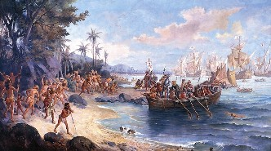  Portuguese arrive in Brazil (above). | Government of Brazil  The government of Brazil is very similar to the United States Government. They have a representative democracy. Their government is split up into the executive, legislative, and judicial branches. The country is split up into states, with representatives from each. The executive branch is only made up of president and vice president. The legislative branch is made up of 81 senates (3 from each state) like the US and the chamber of deputies, which is proportional to the number of people in each state, but there is a minimum number of people. The judicial branch is made up of multiple Federal judicial courts, which are assigned a region. There is also 2 superior courts. There has been corruption in recent years. The former president was arrested. However, it is not as bad now that Michel Temer has the spot as president.  President Michel Temer (left). | Economy of Brazil  Brazil’s current GDP PPP (gross domestic product purchasing power parity or how much a country makes a year) is $3.1 trillion, making a GDP per capita (average yearly income per person) of $15,242. This makes Brazil the 8th largest economy in the world as of early 2018. Brazil’s economy was considered the 153rd freest of all nations by the 2018 Index of Economic Freedom, making it very low on the spectrum. Unemployment (at 11.5%), debt, and inflation (CPI at 8.7%) have been major issues in Brazil since its transition from a dictatorship into a democracy.  Now president, Michel Temer has promised much-needed economic reform. He issued policies to slow the growth of government spending and remove barriers from foreign investment. As a result, debt and unemployment have been eased down to a lower rate than the previous president.  Brazil’s currency is the Brazilian Real, which one of is worth 31 cents. There are a wide variety of industries in Brazil but some of the major industries in Brazil are automobiles, steel, machinery and equipment, agriculture, and textile.
A Planned Vacation to Brazil  We are given $10,000 to plan a vacation to Brazil for 2 people. Here is a good 10-day plan:  March 31st: At 9:00 AM, we leave from O’Hare Airport (Chicago) to Galeão (Rio de Janeiro) on Copa Holdings Airline. This costs $1,860 for a round trip with 2 people. There is a layover at Panamá City and we arrive at 12:29 AM (Rio Time) the next day.  April 1st: We will stay at Miramar by Windsor, which is very close to the Atlantic Ocean. We will stay here until April 5th.  April 5th: At 6:10 PM, we will leave to go to Brasilia on the airline Avianca Brazil. This costs $170 for round trip for 2 people. We will arrive at 8:05 PM.  In Brasilia, we will stay at Grand Bittar* for 3 nights. This will cost $186 for that time.  April 8th: At 6:00 AM, we will leave return back to Rio de Janeiro. We will arrive at 7:50 AM that same day.  We will book another stay at Miramar by Windsor, and we will stay there for the remainder of the trip until April 10th. A total of these 7 nights and 2 stays at Miramar by Windsor costs $770.  April 10: At 1:29 AM, we will fly back to Chicago. We will arrive at 1:07 PM (Chicago Time) There will also be another short layover in Panamá City.  Total Spent: Only $2916 in hotels and flights | Places To Go  Rio de Janeiro:  - Tijuca National Park/Christ the Redeemer  - Ipanema/Leblon Beaches  - Quinta da Boa Vista  - Sugarloaf Mountain  - Jardim Botânico  Brasília:  - Brasília National Park  - Nova Nicolândia (Amusement Park)  - Ferrari Kart (Go-Kart Track)  - Planetarium Brasilia  - Museu Nacional (Art and Cultural Museum)  - Alvorada Palace  Why You Should Go to Brazil  Though the Brazilian government and economy are still in recovery, that shouldn't concern vacationers, who get to enjoy the clean and beautiful beaches of Brazil along with its amazing infrastructure. There are many places to go in just the two major cities talked about in the planned vacation (you have national parks, tourist attractions, and places for fun). In addition, being close to the equator allows for tropical weather year-round in most areas of the country. Brazil is distinguishably unique from all the other 25 countries of Latin America due to exotic Portuguese influence as opposed to Spanish or French. This provides a unique and exquisite feel to flourishing Brazilian nation, a reason why many people are flocking here for summer vacation and winter break! | Brazil  Welcome To Paradise  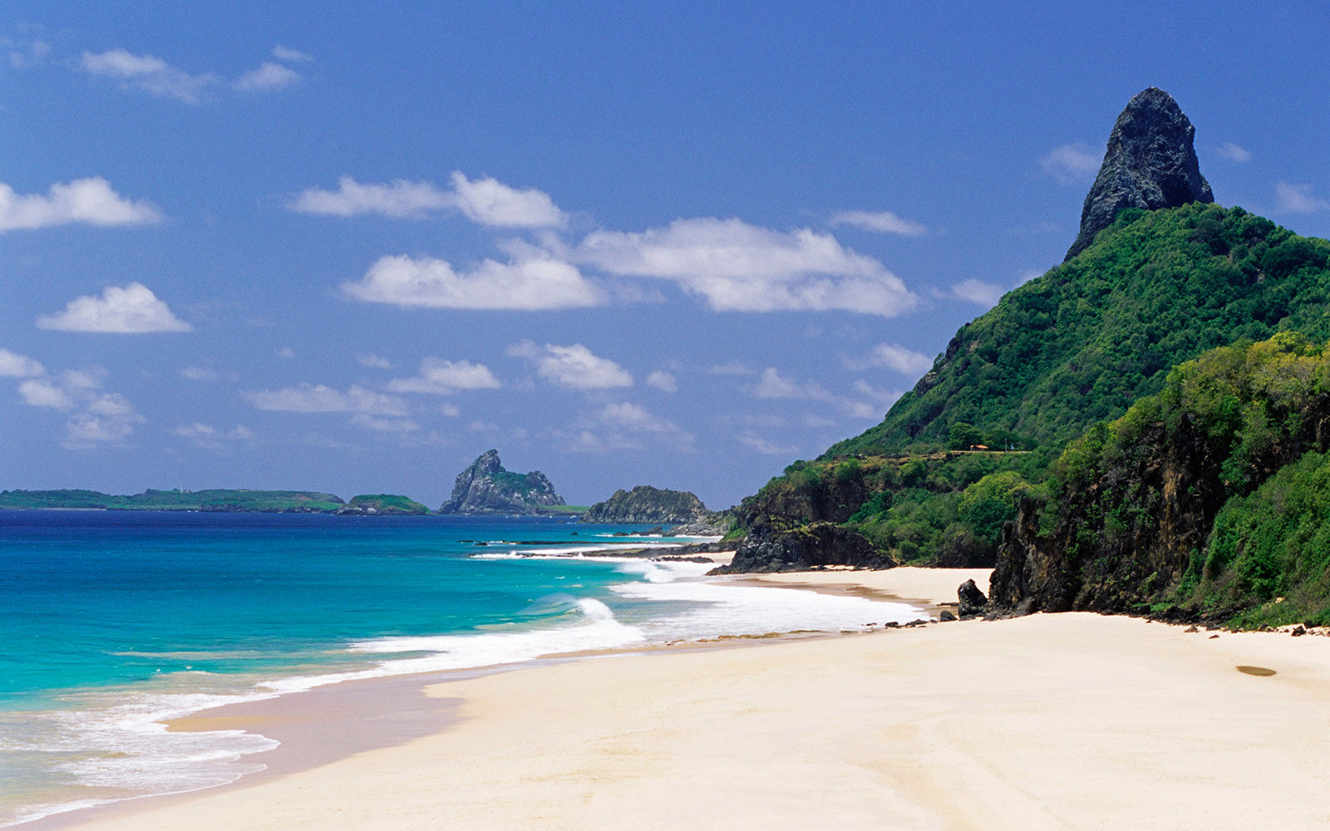  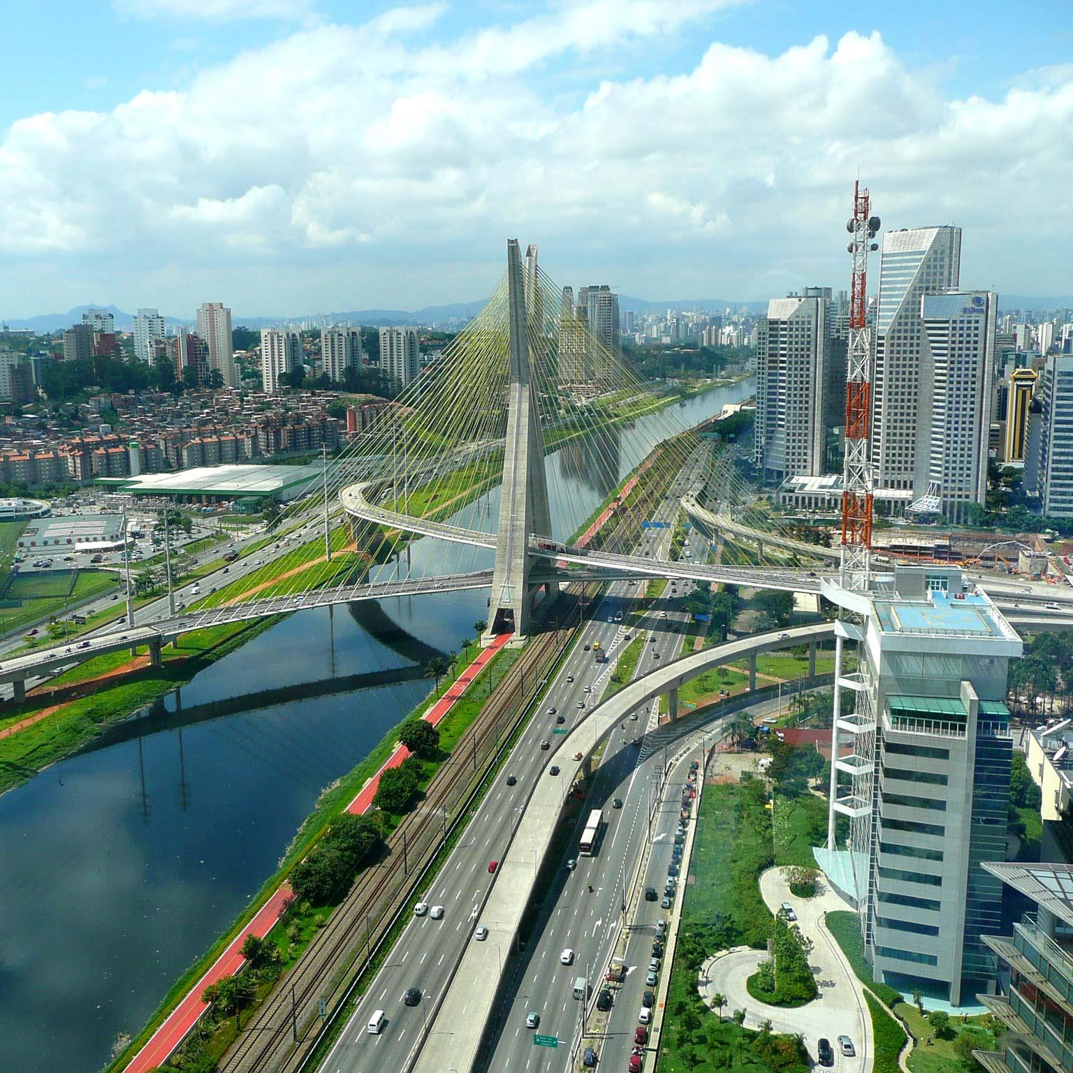  By:  Kyle Sabo &  Mirza Mehmedagic

Round-Trip Flight from Chicago to Rio ($1860):
https://www.google.com/flights/#search;f=ORD,MDW;t=GIG,SDU;d=2018-03-31;r=2018-04-10;sel=ORDPTY0CM236-PTYGIG0CM873,GIGPTY0CM872-PTYORD0CM228;px=2
Round-Trip Flight from Rio to Brasilia ($170):
https://www.google.com/flights/#search;f=GIG,SDU;t=BSB;d=2018-04-05;r=2018-04-08;sel=GIGBSB0O66214,BSBGIG0O66217;px=2
Hotel in Rio ($110 per night * 7 nights = total $770):
http://windsorhoteis.com/hotel/windsor-barra/
Hotel in Brasilia ($62 per night * 3 nights = total $186):
https://hoteisbittar.com.br/grand_bittar/site/index.php

